Andres Blandon

**CA1 handsonipconfig**

1.4 –

A. ipconfig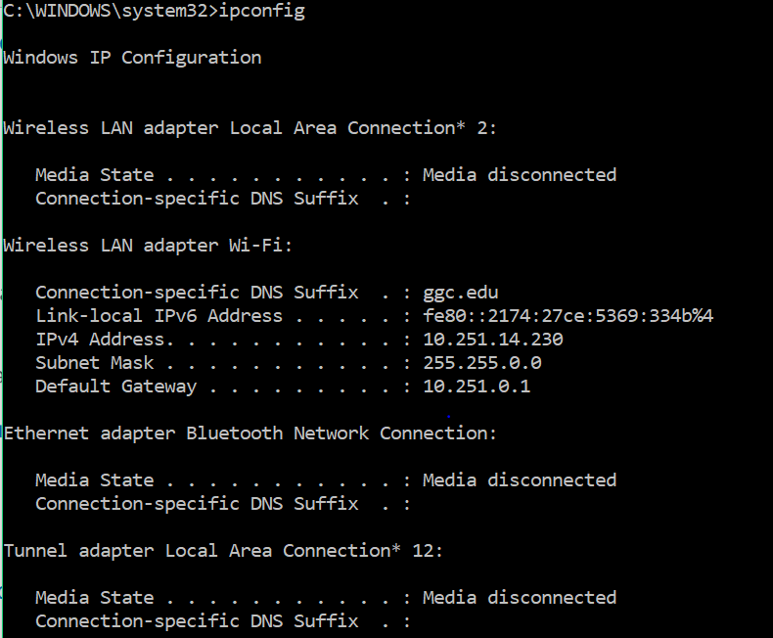

ipconfig \a

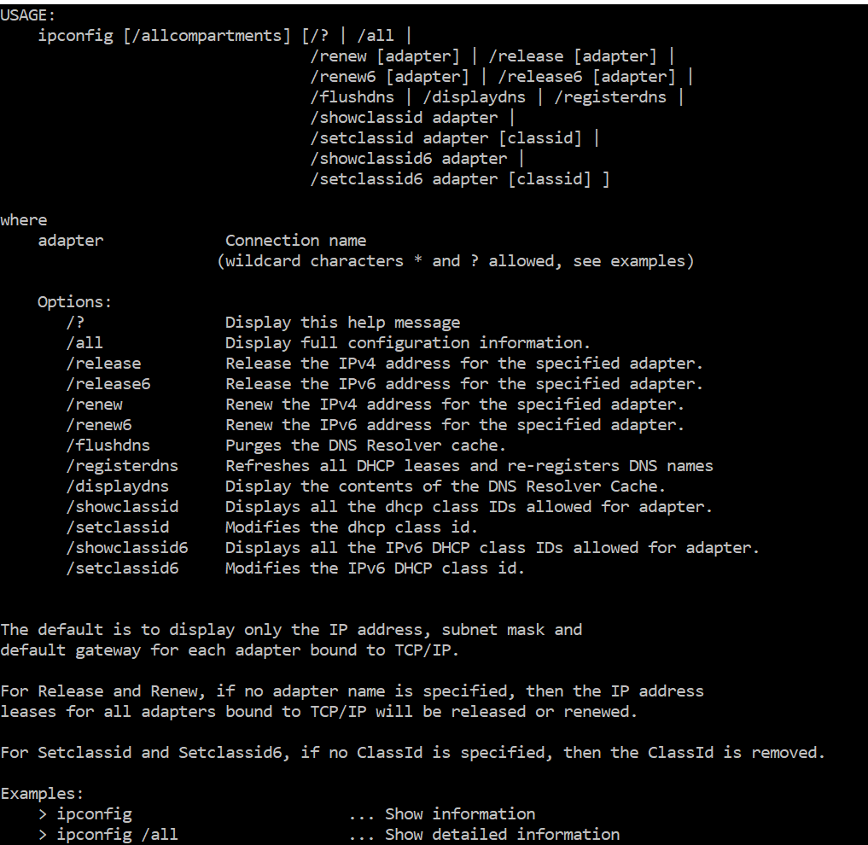

B. ping google.com

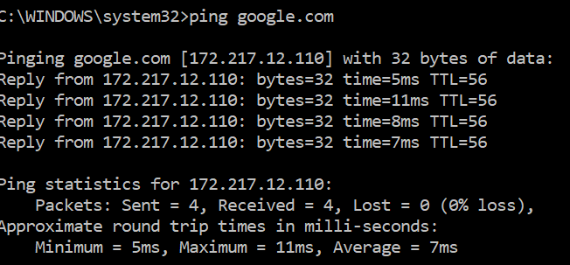

C. arp -a

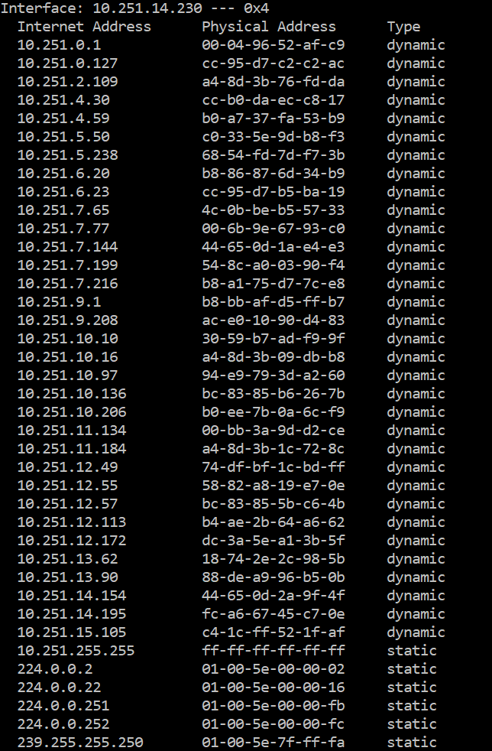

1.8 –

**ipconfig** - a console application that displays all current TCP/IP network configuration values and can modify Dynamic Host Configuration Protocol (DHCP) and Domain Name System (DNS) settings

**ping** - computer network administration software utility used to test the reachability of a host on an Internet Protocol (IP) network

**Address Resolution Protocol (arp)** -  protocol for mapping an Internet Protocol address (IP address) to a physical machine address that is recognized in the local network

2.6 –

A. tracert google.com

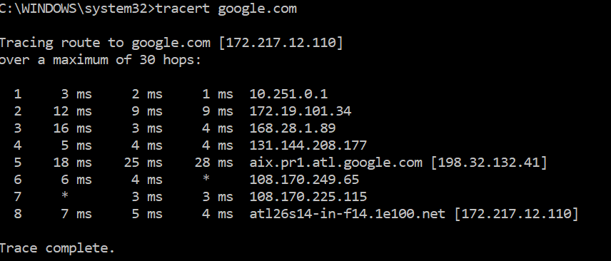

B. <http://www.monitis.com/traceroute/index.jsp?url=steam.com&testId=1802099>

Trace for steam.com